Creating a Blog Entry

A blog is a collaborative tool that allows you to post personal reflections about the course or discuss and analyze course related materials. Each blog entry can include any combination of text, images, links, multimedia, and attachments.

There are three types of blogs: individual, group, or course blogs. An individual blog belongs only to one student, and only that student can contribute to it. Other students can still comment on the entries as the instructor allows. A group blog can be used for group projects in a group space. Only members of that particular group have access to it. In a course blog, all students can participate and contribute to the blog.

A blog icon looks like a comment bubble with lines for text. Click the title to create your entry.

After clicking on the blog title, you will arrive at the blog overview. This page contains the instructions. If you have posted to the blog previously, you will find those posts listed below.

You can see the type of blog and your total number of entries and comments by clicking the Blog Details down arrow on the right.

To add your own entry to the blog, click the button. Enter a title and click into the Entry Message text box and type your post. Clicking the three dots button in the text editor will expand it, giving you more options.

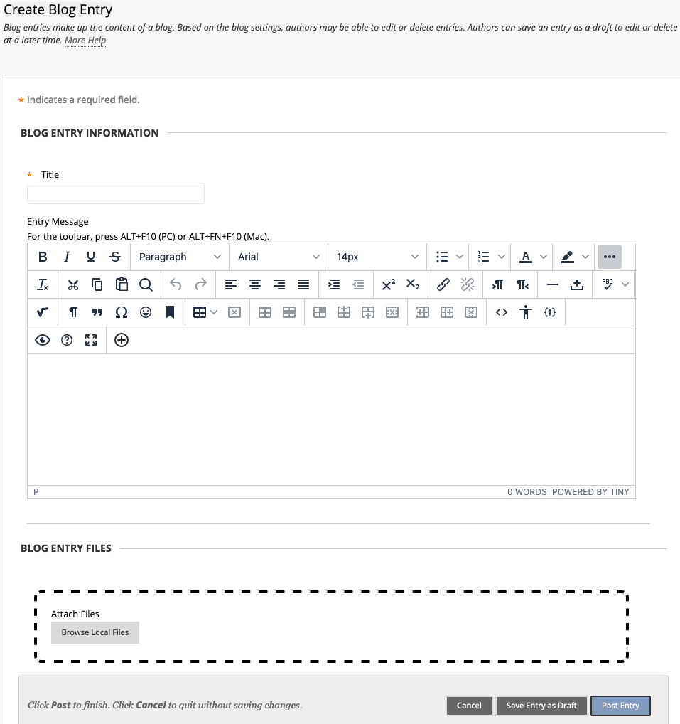

Click 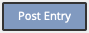 when you have completed your blog post.
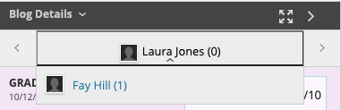
You can read your classmates’ blog posts by clicking the down arrow under your name in the Blog Details area. Click on a classmates’ name to open and read their post.
Instructors and students can enter comments on blog posts if the instructor has enabled them. To add comments, at the bottom of the blog post, click the button.

Enter a comment in the Comment field and click Add. You can view comments by clicking Comments beneath an entry.

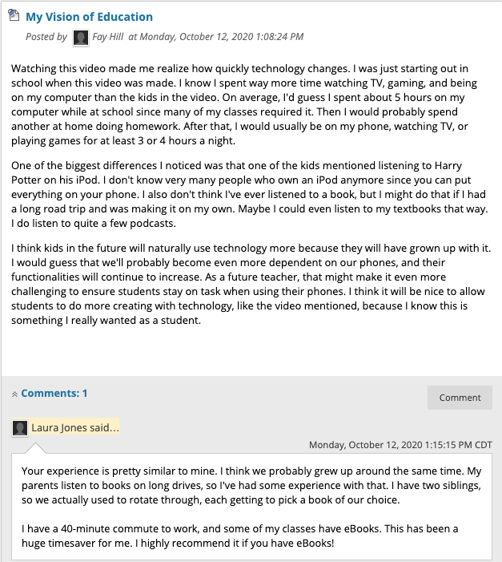

Blogs created in Blackboard can only be viewed from Blackboard; they are not publicly accessible. These blogs do not support RSS, so you cannot subscribe for updates to the blog. The only way to check for a new blog entry or comments is to navigate the blog in Blackboard.

